Kent E. Kroehler - Brief Bio (Sept. 11, 2017)

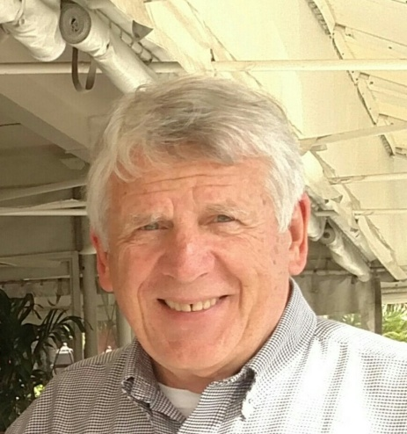
Kent Kroehler is a UMC clergy (retired) from Eastern PA. He served for 45 years in Philadelphia and Lancaster PA and as Conference staff for 8 years. He used a Lilly Endowment "Clergy Renewal Grant" to bicycle across the USA in 2002, and buoyed his final decade of ministry.

Kent earned his BA at Asbury University, his M.Div. at Asbury Theological Seminary, and his D.Min. at Wesley Theological Seminary. He and Joy have been married for 52 years. They have 3 children and 7 grandchildren.

In retirement, he has a passion for creating a culture of extravagant generosity in God’s people. He serves on the Mid-Atlantic UM Foundation Board, chairs the MAUMF Stewardship Committee, and is a Group Facilitator with the MAUMF Financial Leadership Academy. He chairs the Board of Sudan Rebirth Ministry, providing scholarships for South Sudanese students in east Africa. In Lancaster, he serves with Have a Heart for Persons in the Criminal Justice System, Anchorage Breakfast Ministry Board, the West District Board of Church Location and Building, leads a maintenance team at First UMC, and sings in two church choirs.

